**#1 Graph DB (ver1.2)**

**편집 주소:**

D<https://drive.google.com/file/d/1tZP8hUFYugUbauDsqwsuGL97zilQw04u/view?usp=sharing>

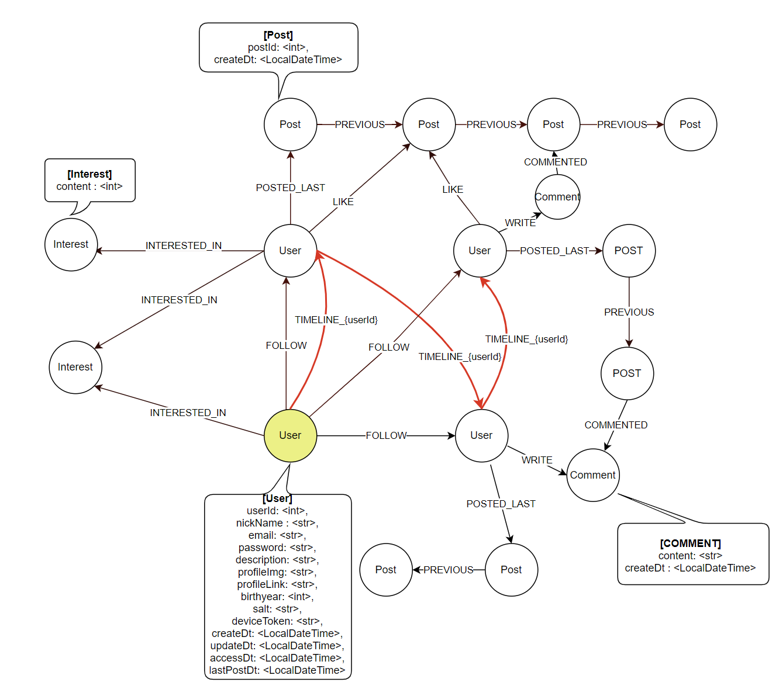

* GraphDB 변경 이력

|  |  |  |
| --- | --- | --- |
| 버전 | 날짜 | 변경내역 |
| 1.2 | 1/22 | * 포스트 및 사용자 linked list 형식으로 유지 * ERD에서 이전으로 필드 추가 |

**#2 mongoDB (ver1.1)**

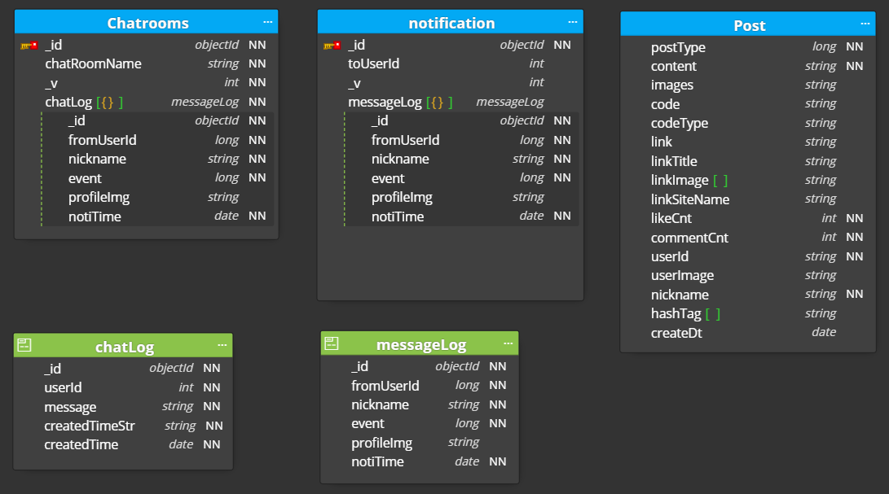

* mongoDB 변경 이력

|  |  |  |
| --- | --- | --- |
| 버전 | 날짜 | 변경내역 |
| 1.0 | 1/25 | Mongodb 모델링 생성 |
| 1.1 | 2/05 | ChatLog userId 필드 추가 |

**~~#3 ERD (ver 1.9)~~**

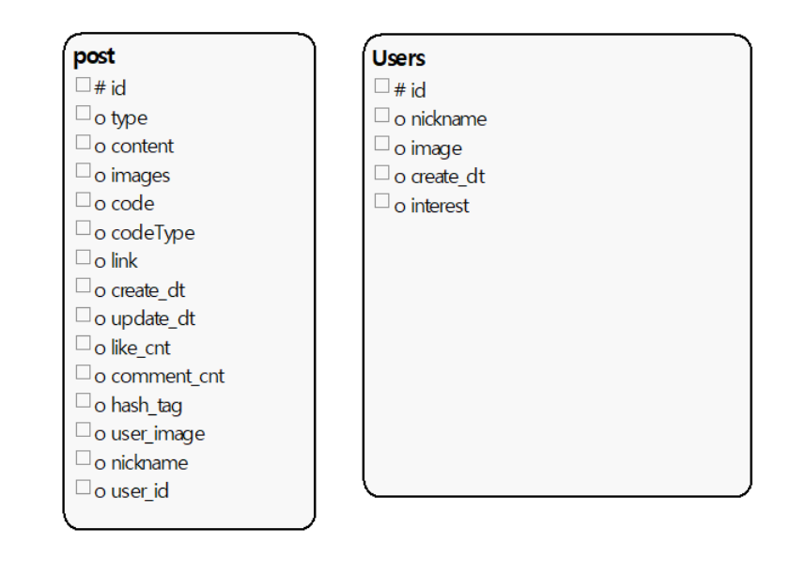

* ERD 변경 이력

|  |  |  |
| --- | --- | --- |
| 버전 | 날짜 | 변경내역 |
| 1.4 | 21.01.06 | * Interest 테이블 type 속성 삭제 |
| 1.5 | 21.01.07 | * + Like 테이블 예약어로 Likes로 명칭 변경 |
| 1.6 | 21.01.10 | * + Follow table   id속성 제거하고 (users_id, post_id) 를 pk로 지정   * + Likes table   id속성 제거하고 (from_user_id, to_user__id) 를 pk로 지정 |
| 1.7 | 21.01.12 | * + Post table   멘토링 피드백 반영 (comment_cnt, like_cnt 추가) |
| 1.8 | 21.01.12 | * + User table   속성 salt추가 |
| 1.9 |  | **MongoDB로 이전으로 해당 ERD 삭제** |

**[참조 #1 - ERD v1.8]**

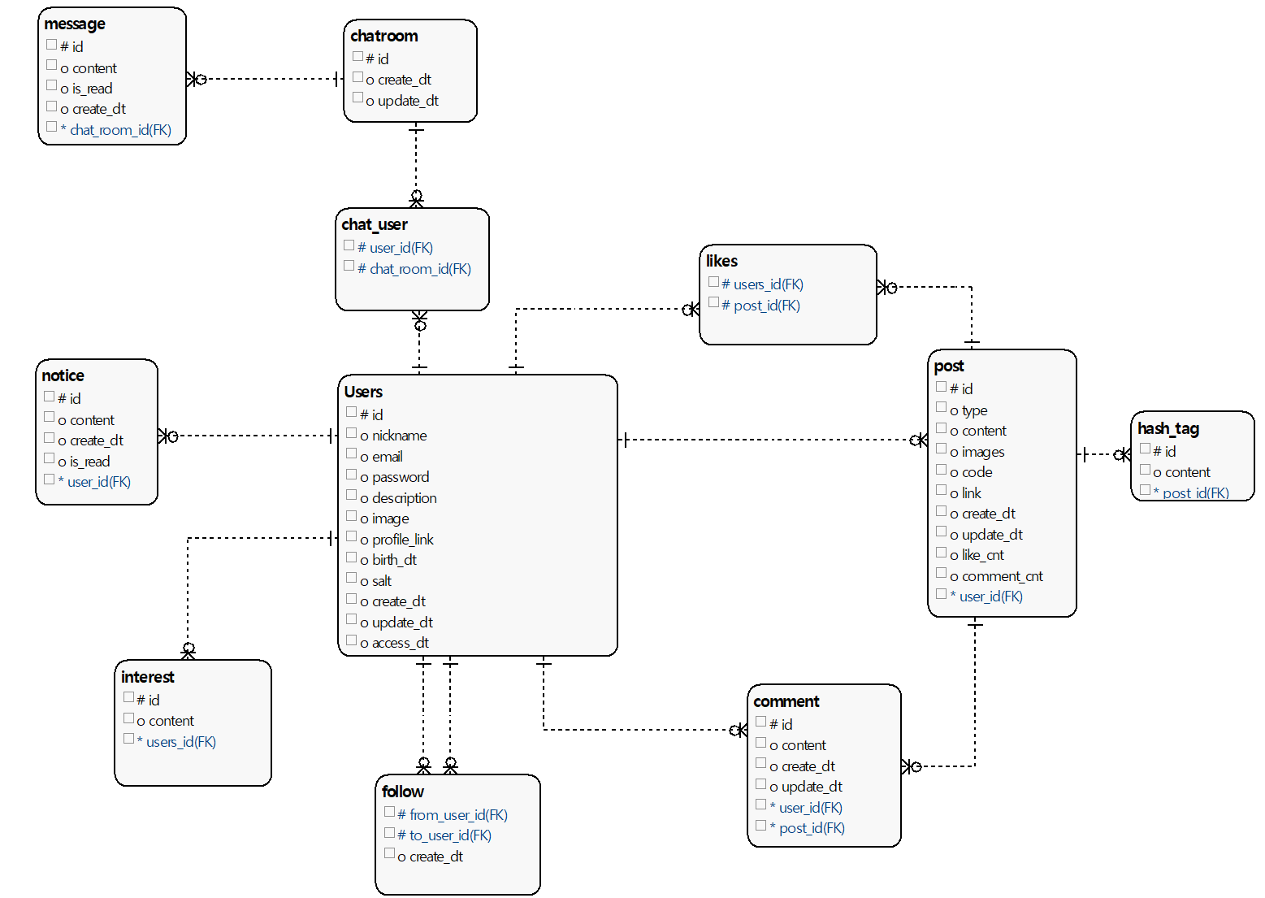

**[참조 #2 - Graph DB 설계방법]**

-URL : <http://www.apcjones.com/arrows/>#

* 설계 소스코드

|  |
| --- |
| <ul class="graph-diagram-markup" data-internal-scale="1.9" data-external-scale="1">  <li class="node" data-node-id="0" data-x="-148.99328859060407" data-y="-114.76510067114098">  <span class="caption">User</span><dl class="properties"><dt>id</dt><dd>125</dd></dl></li>  <li class="node" data-node-id="1" data-x="-148.99328859060407" data-y="-434.22147651006674">  <span class="caption">User</span><dl class="properties"><dt>id</dt><dd>124</dd></dl></li>  <li class="node" data-node-id="2" data-x="362.9914758492886" data-y="-434.22147651006674">  <span class="caption">Post</span><dl class="properties"><dt>id</dt><dd>259</dd></dl></li>  <li class="node" data-node-id="3" data-x="362.9914758492886" data-y="-114.76510067114098">  <span class="caption">Post</span><dl class="properties"><dt>id</dt><dd>258</dd></dl></li>  <li class="node" data-node-id="4" data-x="723.7814581994984" data-y="-114.76510067114098">  <span class="caption">HashTag</span><dl class="properties"><dt>content</dt><dd>"develop"</dd></dl></li>  <li class="node" data-node-id="5" data-x="723.7814581994984" data-y="-434.22147651006674">  <span class="caption">HashTag</span><dl class="properties"><dt>content</dt><dd>"study"</dd></dl></li>  <li class="node" data-node-id="6" data-x="-532.4067046336637" data-y="-434.22147651006674">  <span class="caption">Interest</span><dl class="properties"><dt>content</dt><dd>"java"</dd></dl></li>  <li class="node" data-node-id="7" data-x="-532.4067046336637" data-y="-114.76510067114098">  <span class="caption">Interest</span><dl class="properties"><dt>content</dt><dd>"algorithm"</dd></dl></li>  <li class="node" data-node-id="8" data-x="-148.99328859060407" data-y="187.88672696627106">  <span class="caption">User</span><dl class="properties"><dt>id</dt><dd>124</dd></dl></li>  <li class="node" data-node-id="9" data-x="362.9914758492886" data-y="187.88672696627106">  <span class="caption">POST</span><dl class="properties"><dt>id</dt><dd>259</dd></dl></li>  <li class="relationship" data-from="0" data-to="1">  <span class="type">FOLLOW</span>  </li>  <li class="relationship" data-from="1" data-to="2">  <span class="type">POSTED</span><dl class="properties"><dt>createDt</dt><dd>"2020-01-02"</dd></dl></li>  <li class="relationship" data-from="0" data-to="2">  <span class="type">LIKE</span>  </li>  <li class="relationship" data-from="0" data-to="3">  <span class="type">POSTED</span><dl class="properties"><dt>createDt</dt><dd>"2020-01-05"</dd></dl></li>  <li class="relationship" data-from="3" data-to="4">  <span class="type">TAG</span>  </li>  <li class="relationship" data-from="2" data-to="5">  <span class="type">TAG</span>  </li>  <li class="relationship" data-from="2" data-to="4">  <span class="type">TAG</span>  </li>  <li class="relationship" data-from="1" data-to="6">  <span class="type">INTERESTED_IN</span>  </li>  <li class="relationship" data-from="0" data-to="7">  <span class="type">INTERESTED_IN</span>  </li>  <li class="relationship" data-from="0" data-to="8">  <span class="type">FOLLOW</span>  </li>  <li class="relationship" data-from="8" data-to="3">  <span class="type">COMMENT</span>  </li>  <li class="relationship" data-from="8" data-to="7">  <span class="type">INTERESTED_IN</span>  </li>  <li class="relationship" data-from="1" data-to="7">  <span class="type">INTERESTED_IN</span>  </li>  <li class="relationship" data-from="8" data-to="9">  <span class="type">COMMENT</span>  </li>  <li class="relationship" data-from="8" data-to="9">  <span class="type">LIKE</span>  </li>  </ul> |